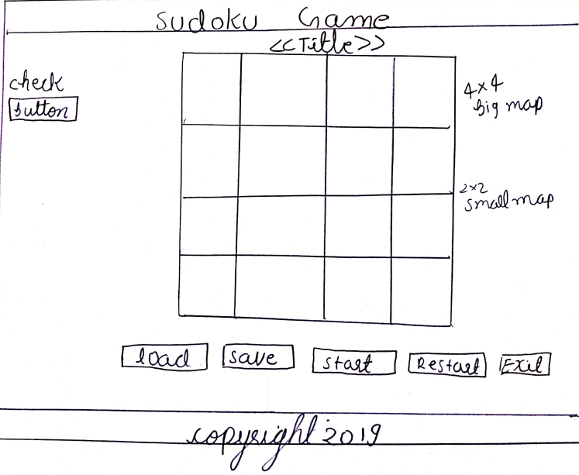

**Scenario:** size 4, square width 2 and square height 2

* When the user clicks on the game this is the initial screen that will be shown without the map for the Sudoku.
* To play the game, the user must first click on the button "Load" and select the CSV file to generate the map.
* If the CSV file is not in correct format or empty an error message will be shown.
* The user will be given a built-in three maps by the developer but a user can create another map by setting map size from the Sudoku Map Screen.
* Once the map is generated the user has to click on the "start" button that let the user insert the number.
* All the number should be a single-digit number.
* Once the user is happy with all the placement of the number, the user can click on the "check" button to verify, if the numbers are unique in rows, column and square.
* If the numbers are unique the user will be given a message "You have solved the puzzle" and if numbers are similar in columns or rows the message saying "Please try again".
* The user can also save the puzzle by clicking on the "save" button. When the "save" button is pressed it automatically generated the map and the map is saved in the folder "Game Map".
* When the user clicks on the "restart" button all the insert number will be removed and the user can start solving the puzzle from beginning.
* When the user wants to quit the game, the user can just click on the "Exit" button.

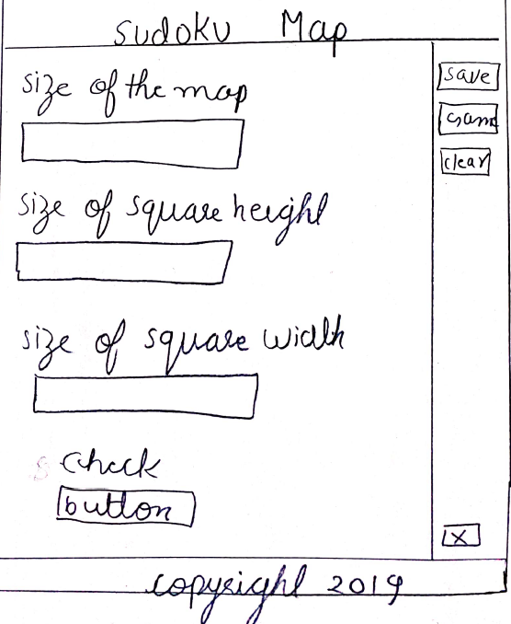

**Scenario**: The user wants to create their map.

* Once the user enters this screen they will be given an option to change the size of the map. In addition to this, they can also change the square height and width.
* Once the three field is inserted, the user must click on the "Check" button to see the input is a valid number to generate the map.
* If the number is valid messages will be shown saying " Successful " and on the other hand in case of invalid a message saying "unsuccessful " will be shown.
* In addition to this, if the save button is pressed without entering the number and checking them an empty file will be created.
* Once the message is "Successful" the user must click on the "save" button to save the custom map.
* To play the game the user must go to the game screen and load the custom map.
* If the user wants all their input field to be clear, the user can click on the "clear" button.
* Clicking on the cross button will exit the screen.